Course: Computer Networks (Lab)
Faculty: Mohsin Mubeen Abbasi
Submitted by:
Shumaila Arif (68279)
Title:
City-Wide Corporate Network Design Using Cisco Packet Tracer
Motivation:
The motivation behind this project was to gain practical experience in designing, configuring, and managing a city-wide network using Cisco Packet Tracer. As students of computer networks, it is essential to bridge the gap between theoretical knowledge and real-world application. Through this project, we aimed to understand how different networking components—such as IP addressing, subnetting, routing protocols (RIP v2), and topologies—work together to form a functional and efficient network.
By simulating a network that connects multiple companies across a city, we were able to learn how to plan scalable and cost-effective infrastructure while ensuring reliable interconnectivity. This hands-on experience prepares us for future challenges in network engineering and IT management roles.

Concept (Problem Statement):
In a growing urban environment, multiple companies often need to communicate and share resources across different locations. Setting up dedicated physical connections between each site is not only costly but also difficult to manage and scale. Therefore, there is a need for a cost-effective, scalable, and reliable network solution that can interconnect multiple companies while supporting internal communication within each organization.
The challenge is to design a city-wide network that allows three different companies—Company X, Company Y, and Company Z—to operate independently within their LANs while also being able to communicate efficiently across the entire network. The network must ensure optimal utilization of IP addresses through proper subnetting, efficient routing using dynamic protocols, and minimal use of hardware to reduce costs. Additionally, the network should support future expansion without significant redesign.

Design:

The design of the network was structured around the requirements of three companies (X, Y, Z) with varying numbers of rooms and devices. To ensure modularity and clarity, each room was assigned a dedicated switch, and all switches in a company were connected to a central router. This approach follows a star topology within each organization.
To enable communication between companies, all routers were connected using serial links, forming a bus topology for inter-router connections. This hybrid model (star + bus) was selected for its cost-effectiveness, ease of troubleshooting, and scalability.

Network Scenario
The network has been designed in the following way:

Company X
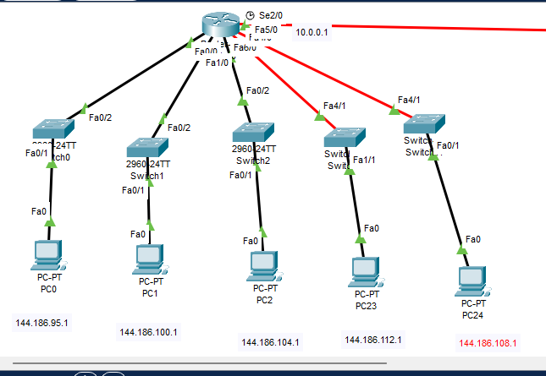
Figure 1 CMP X

Company Y
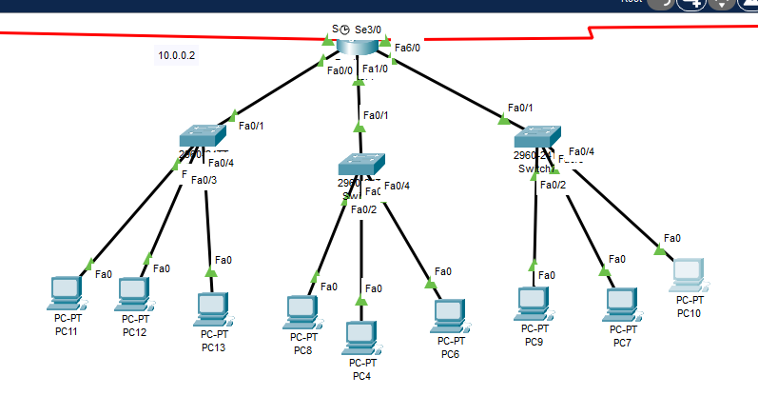Figure 2 CMP Y
Company Z:
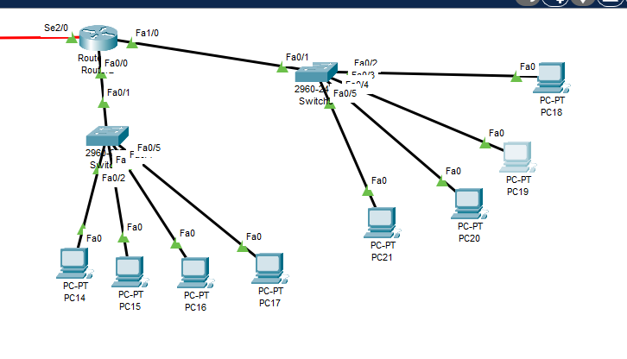

Figure 3 CMP Z

Complete Network Design

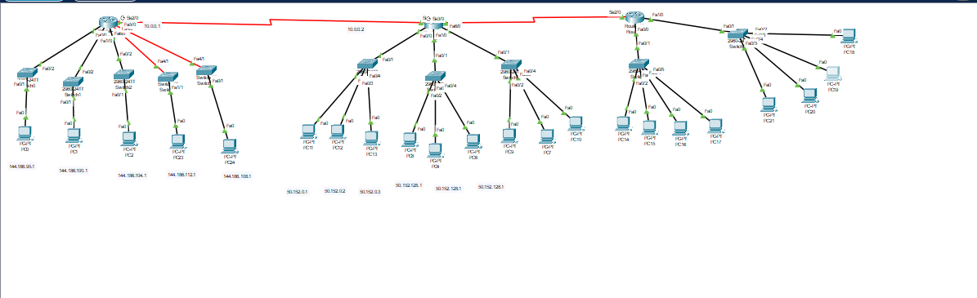
Figure 4 Complete Network Design

Configuration of Subnets
The sub-netting of each network is as follows:

Company X
Given: 144.186.96.0
We need five networks. Which means we will have to borrow three host bits 144.186.96.0/22.
New Subnet Mask -> 255.255.11111100.0 → 255.255.252.0
Calculations
- 144.186.96.0 -> 144.186.011 000 00
- 144.186.100.0 -> 144.186.011 001 00
- 144.186.104.0 -> 144.186.011 010 00
- 144.186.108.0 -> 144.186.011 011 00
5) 144.186.112.0 -> 144.186.011 100 00

Ranges
Subnet | Network Address | Valid Host | Broadcast Address
1. | 144.186.96.0 | 144.186.96.1 - 144.186.99.254 | 144.186.99.255
2. | 144.186.100.0 | 144.186.100.1 - 144.186.103.254 | 144.186.103.255
3. | 144.186.104.0 | 144.186.104.1 - 144.186.107.254 | 144.186.107.255
4. | 144.186.108.0 | 144.186.108.1 - 144.186.111.254 | 144.186.111.255
5. | 144.186.112.0 | 144.186.112.1 - 144.186.115.254 | 144.186.115.255

Company Y
Given: 50.152.0.0/15
We need 3 networks. Which means we will have to borrow two host bits 50.152.0.0/17.
New Subnet Mask -> 255.10011000.0.0 → 255.255.128.0
Calculations
- 50.152.0.0 -> 50.10011000.00000000.0
- 50.152.128.0 -> 50.10011000.10000000.0
- 50.153.0.0 -> 50.10011001.00000000.0

Ranges
Subnet | Network Address | Valid Host | Broadcast Address
1. | 50.152.0.0 | 50.152.0.1 - 50.152.127.254 | 50.152.127.255
2. | 50.152.128.0 | 50.152.128.1 - 50.152.255.254 | 50.152.255.255
3. | 50.153.0.0 | 50.153.0.1 - 50.153.0.128 | 50.153.0.129

Company Z
Given: 210.98.169.64/26
We need 2 networks. Which means we will have to borrow one host bit 210.98.169.64/27
New Subnet Mask -> 255.255.255.11100000 → 255.255.255.224
Calculations
- 210.98.169.64 -> 210.98.169.01000000
- 210.98.169.96 -> 210.98.169.01100000

Ranges
Subnet | Network Address | Valid Host | Broadcast Address
1. | 210.98.169.64 | 210.98.169.65 - 210.98.169.94 | 210.98.169.95
2. | 210.98.169.96 | 210.98.169.97 - 210.98.169.126 | 210.98.169.127

Routers Serial Communication
In this I use class c network ip and default gateway.

Ranges
Subnet | Network Address | Subnet mask
1. | 10.0.0.0 | 255.255.255.0
2. | 11.0.0.0 | 255.255.255.0

Configuration of LANs

Configuration of PCs
All the PCs in the networks were assigned static IP addresses.

Company X
Name | IP address | Subnet | Gateway
PC-PT PC0 | 144.186.96.1 | 255.255.252.0 | 144.186.96.2
PC-PT PC1 | 144.186.100.1 | 255.255.252.0 | 144.186.100.2
PC-PT PC2 | 144.186.104.1 | 255.255.252.0 | 144.186.104.2
PC-PT PC3 | 144.186.112.1 | 255.255.252.0 | 144.186.112.2
PC-PT PC5 | 144.186.108.1 | 255.255.252.0 | 144.186.108.2

Company Y
Name | IP address | Subnet | Gateway
PC-PT PC11 | 50.152.0.1 | 255.255.128.0 | 50.152.0.4
PC-PT PC12 | 50.152.0.2 | 255.255.128.0 | 50.152.0.4
PC-PT PC13 | 50.152.0.3 | 255.255.128.0 | 50.152.0.4
PC-PT PC8 | 50.152.128.1 | 255.255.252.0 | 50.152.128.4
PC-PT PC4 | 50.152.128.2 | 255.255.252.0 | 50.152.128.4
PC-PT PC6 | 50.152.128.3 | 255.255.252.0 | 50.152.128.4
PC-PT PC9 | 50.153.0.1 | 255.255.128.0 | 50.153.0.4
PC-PT PC7 | 50.153.0.2 | 255.255.128.0 | 50.153.0.4
PC-PT PC 10 | 50.153.0.3 | 255.255.128.0 | 50.153.0.4

Company Z
Name | IP address | Subnet | Gateway
PC-PT PC14 | 210.98.169.65 | 255.255.255.224 | 210.98.169.69
PC-PT PC15 | 210.98.169.66 | 255.255.255.224 | 210.98.169.69
PC-PT PC16 | 210.98.169.67 | 255.255.255.224 | 210.98.169.69
PC-PT PC17 | 210.98.169.68 | 255.255.255.224 | 210.98.169.69
PC-PT PC21 | 210.98.169.97 | 255.255.255.224 | 210.98.169.101
PC-PT PC20 | 210.98.169.98 | 255.255.255.224 | 210.98.169.101
PC-PT PC19 | 210.98.169.99 | 255.255.255.224 | 210.98.169.101
PC-PT PC18 | 210.98.169.100 | 255.255.255.224 | 210.98.169.101

Configuration of Gateways Company X
Name | Gateway Address
Switch0 | 144.186.96.2
Switch1 | 144.186.100.2
Switch2 | 144.186.104.2
Switch3 | 144.186.112.2
Switch4 | 144.186.108.2

Company Y
Name | Gateway Address
Switch10 | 50.152.0.4
Switch5 | 50.152.128.4
Switch6 | 50.153.0.4

Company Z
Name | Gateway Address
Switch8 | 210.98.169.69
Switch9 | 210.98.169.101

Configuration of Routers
Routers were set up using the CLI interface.
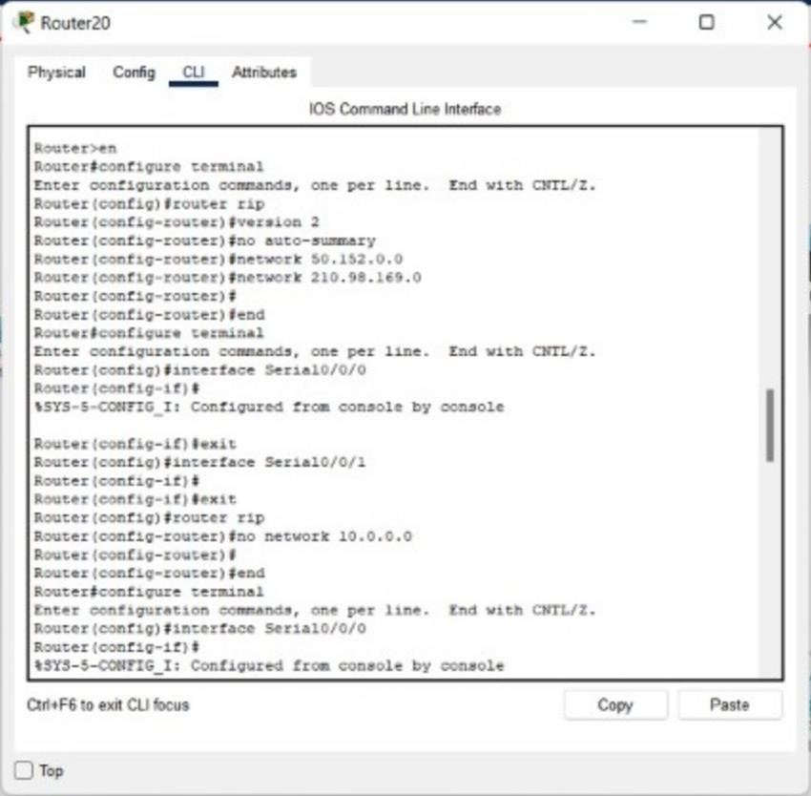
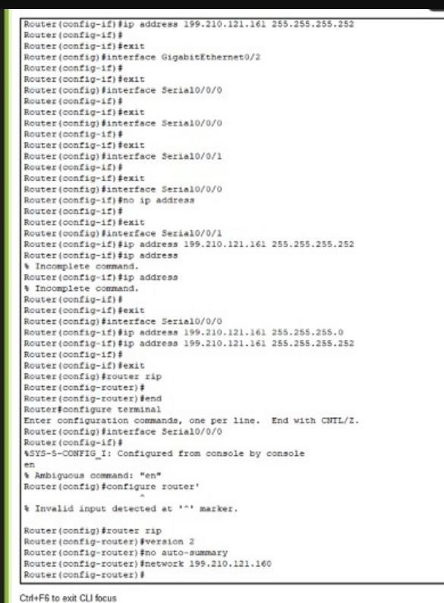

The other routers were set up similarly.

Company X
Name | Serial IP | Subnet | Network IP
Router0 | 10.0.0.1 AND 10.0.0.2 | 255.0.0.0 | 10.0.0.0

RIP of Company X

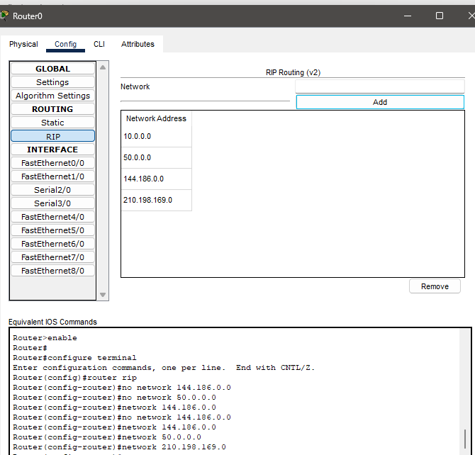

Company Y
Name | Serial IP | Subnet | Network IP
Router1 | 10.0.0.2 AND 11.0.0.1 | 255.0.0.0 | 10.0.0.0 AND 11.0.0.0

RIP of Company Y

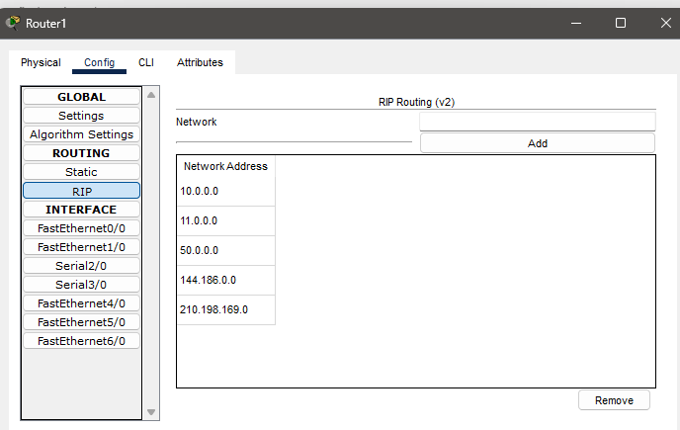

Company Z
Name | Seriel IP | Subnet | Network IP
Router2 | 11.0.0.2 | 255.0.0.0 | 11.0.0.0

RIP of Company Z
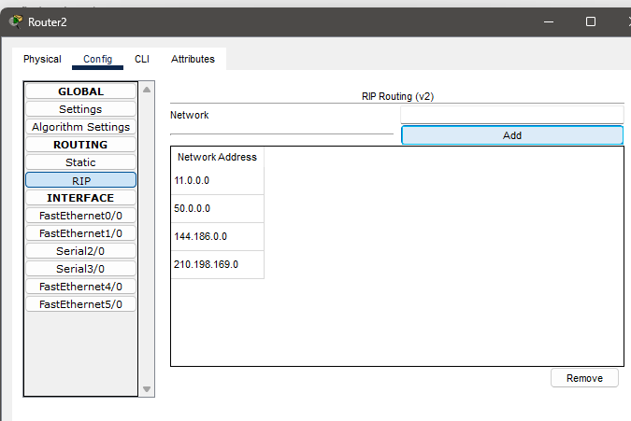
Ping Results

DELEVERABLES:
- Cisco Packet Tracer project file (.pkt) showing full network implementation
- Complete project report (.docx) with design, configuration, and results
- Subnetting and IP addressing plan
- RIP v2 routing configuration details
- Ping test results verifying successful inter-company communication

Procedure / Methodology:
The following steps were carried out to complete the city-wide corporate network design:
- Planning and IP Allocation
  - Studied the requirements of all three companies.
  - Allocated a unique IP block to each company (Company X, Y, Z).
  - Subnetted each network based on the number of rooms and PCs.
- Network Topology Design in Cisco Packet Tracer
  - Added routers, switches, and PCs as per the company structure.
  - Used one switch per room and connected it to a central router.
  - Connected routers using serial DCE/DTE cables to form a bus topology.
- Device Configuration
  - Assigned static IP addresses to all PCs.
  - Configured default gateways on each PC pointing to the switch interface.
- Router Configuration
  - Used the CLI (Command Line Interface) to configure interfaces.
  - Assigned IP addresses to FastEthernet and Serial ports.
  - Enabled and configured RIP version 2 for dynamic routing.
  - Verified connectivity between routers.
- Testing and Validation
  - Performed ping tests between devices within each LAN.
  - Then tested cross-company pings (e.g., PC0 → PC14).
  - All devices successfully communicated after RIP propagation.
- Documentation
  - Captured screenshots of the topology, router configurations, and ping results.
  - Compiled the report with subnetting details, analysis, and results.

Subnetting Details
Company X (144.186.96.0/19)
Required: 5 networks → Borrowed 3 bits → /22 subnet mask (255.255.252.0)
Subnet | Network Address | Valid Hosts | Broadcast Address
1 | 144.186.96.0 | 144.186.96.1 - 144.186.99.254 | 144.186.99.255
2 | 144.186.100.0 | 144.186.100.1 - 144.186.103.254 | 144.186.103.255
3 | 144.186.104.0 | 144.186.104.1 - 144.186.107.254 | 144.186.107.255
4 | 144.186.108.0 | 144.186.108.1 - 144.186.111.254 | 144.186.111.255
5 | 144.186.112.0 | 144.186.112.1 - 144.186.115.254 | 144.186.115.255

Company Y (50.152.0.0/15)
Required: 3 networks → Borrowed 2 bits → /17 subnet mask (255.255.128.0)
Subnet | Network Address | Valid Hosts | Broadcast Address
1 | 50.152.0.0 | 50.152.0.1 - 50.152.127.254 | 50.152.127.255
2 | 50.152.128.0 | 50.152.128.1 - 50.152.255.254 | 50.152.255.255
3 | 50.153.0.0 | 50.153.0.1 - 50.153.0.128 | 50.153.0.129

Company Z (210.98.169.64/26)
Required: 2 networks → Borrowed 1 bit → /27 subnet mask (255.255.255.224)
Subnet | Network Address | Valid Hosts | Broadcast Address
1 | 210.98.169.64 | 210.98.169.65 - 210.98.169.94 | 210.98.169.95
2 | 210.98.169.96 | 210.98.169.97 - 210.98.169.126 | 210.98.169.127

Router Configuration - Serial Communication
Link | IP Range | Subnet Mask
Router0 ↔ Router1 | 10.0.0.0/24 | 255.255.255.0
Router1 ↔ Router2 | 11.0.0.0/24 | 255.255.255.0

PC Configuration (Static IPs)
Each PC is configured with a static IP from the respective subnet. Gateways are configured as the router interfaces connected to each switch.

Routing Protocol
Routing between companies is handled using RIP version 2 to allow dynamic route discovery between networks.

Testing - Ping Results
Initial pings failed due to ARP discovery and RIP propagation delays. All pings were successful after configuration propagation.
Flowchart / Block diagram:
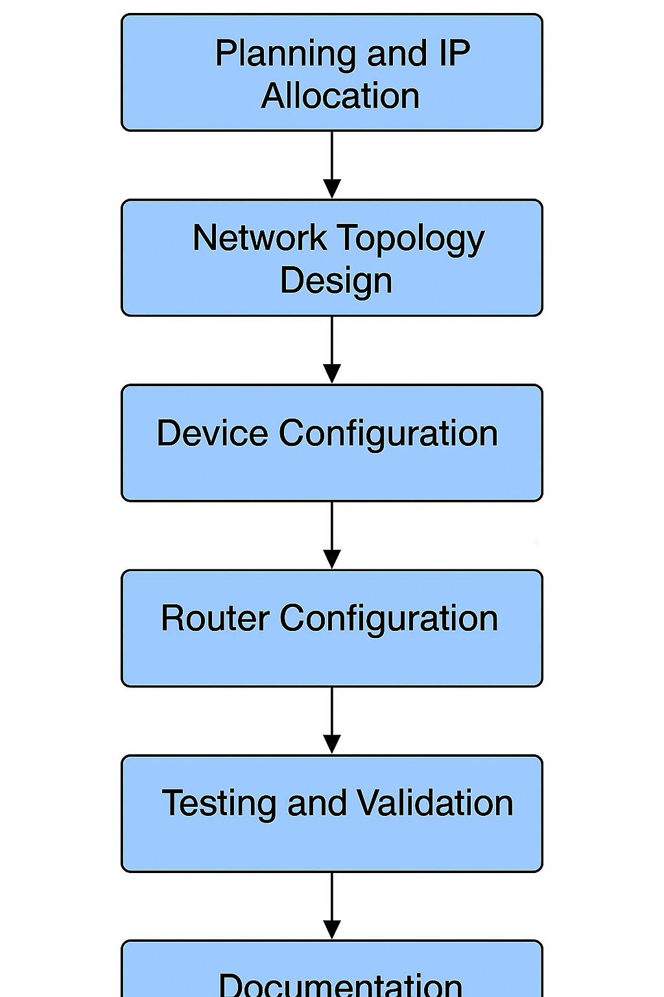
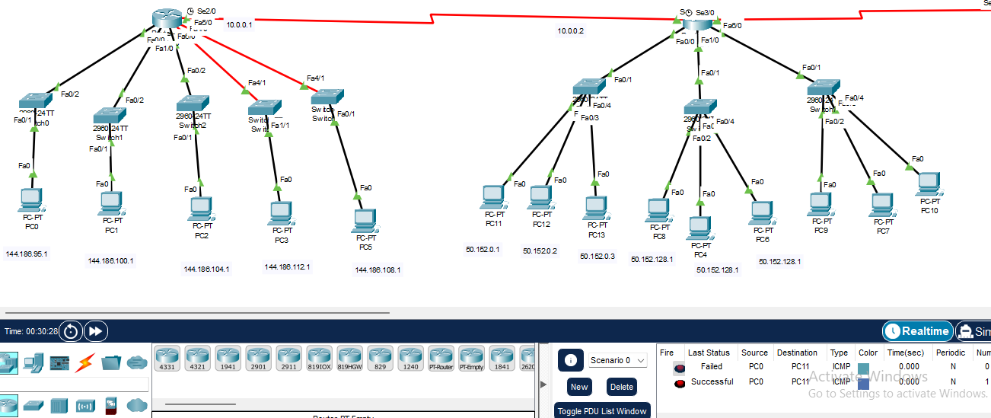
Analysis:
- Our main requirement is to design a network that holds up for three different companies and supports inter-company communication.
- Since we bear the expenses of network design, we have to design a network that is cost-efficient.

Network Design and Structure
Our project is required to make three companies with the following details:
- CMP X with five rooms and one PC in each room
- CMP Y with three rooms and three PCs in each room
- CMP Z with two rooms and four PCs in each room
CMP X utilizes five switches configured over one routers.
CMP Y utilizes three switches configured over one router
CMP X utilizes two switches configured over one router
For the best demonstration of this network structure. We decided to use one switch per room. We further decided to connect routers in such a way that each router would have four connections. Two routers have two serial connections each and two routers have only one serial connection each. This makes for a network that is inexpensive, provides easier management and ensures network flexibility.

Results:

The first message was unsuccessful because the PC0 had not discovered the others within its network. It was successful afterwards.
The third message failed again because the broadcast IP had not gone beyond the network onto the second router. It worked on the second attempt.
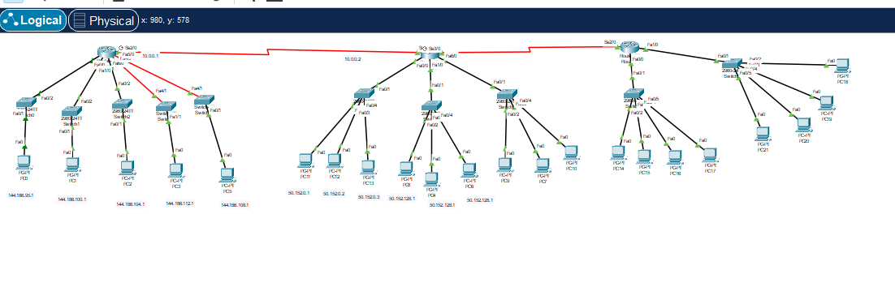
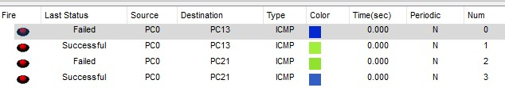
Ping between companies was successful as well.
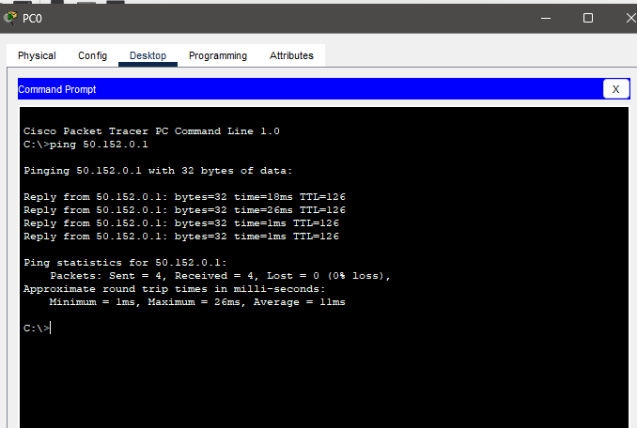

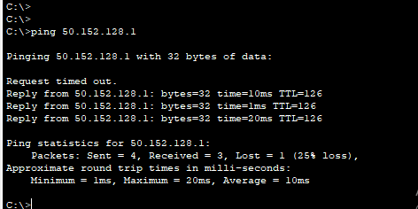

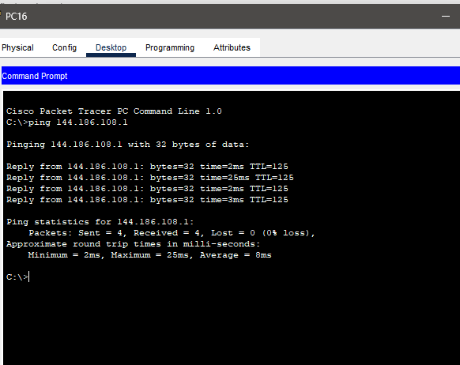

Concluding Remarks:

This project successfully demonstrated how a cost-efficient, scalable city-wide corporate network can be designed using Cisco Packet Tracer. Subnetting, static IP assignment, RIP v2 routing, and serial communication were implemented effectively to connect three companies in a hybrid network topology.
The simulation showed successful inter-company communication with minimal hardware and clear network structure.

